Virtual Lab

**NAME:** Ayush Jain **SAP ID:** 60004200132

**Experiment 1.**

**Aim:**

1. To Study the diffraction occurring due to single slit.
2. To determine ΔY1 the distance between two dark bands surrounding the central bright spot.

**Apparatus:** Laser, screen & ruler.

**Theory:**

When a monochromatic beam of light of wavelength λ arrives at a slit of the width ‘a’ the diffracted light leaving the slits forms a pattern in space. This pattern on the screen is called the diffraction pattern. The number of bands and their distances from the central maximum depends on the width of the slit.

**Diagram:**

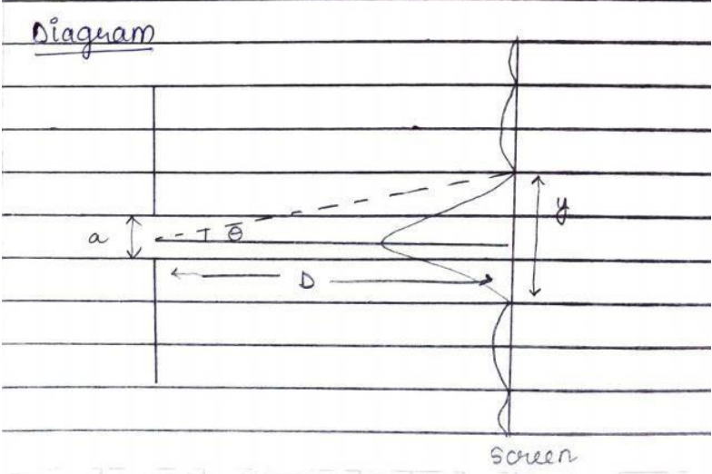

**Observation Table:**

|  |  |  |  |
| --- | --- | --- | --- |
| **a(mm)** | **Λ(nm)** | **ΔS1(mm)** | **ΔY1(mm)= f* ΔS1(mm)** |
| 0.04 | 511 | 18.5 | 24.605 |
| 0.04 | 550 | 20 | 26.6 |
| 0.04 | 600 | 22 | 29.26 |
| 0.04 | 650 | 23 | 30.59 |

**Simulations:**

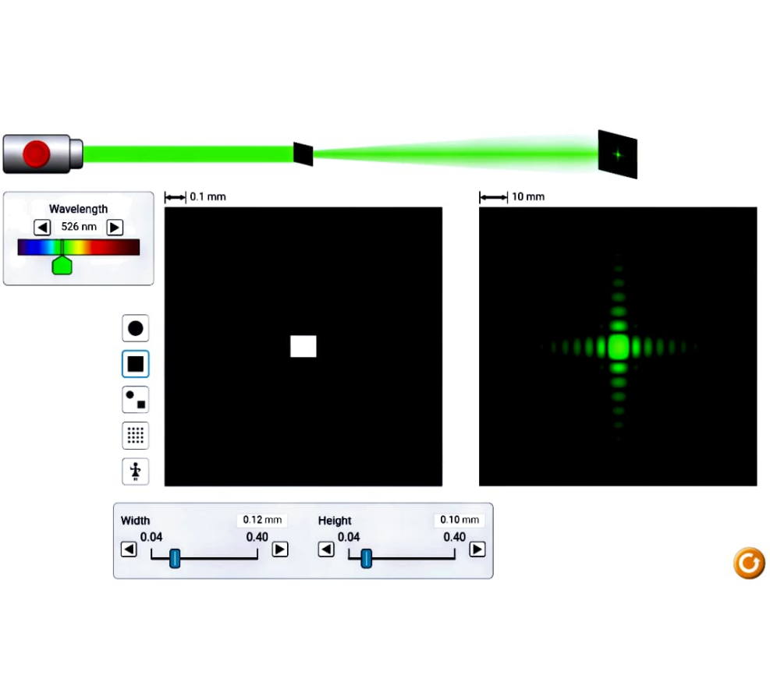

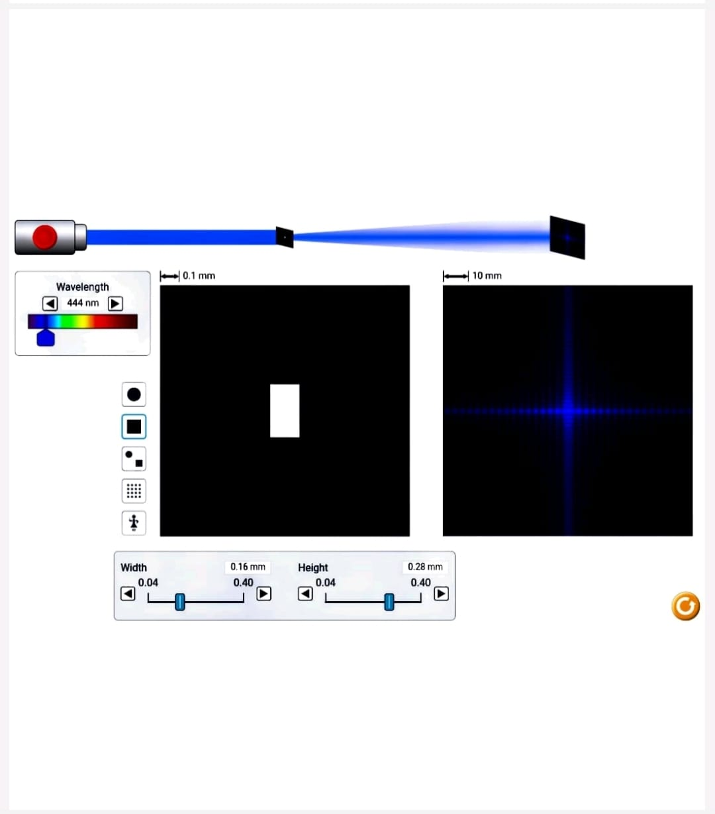

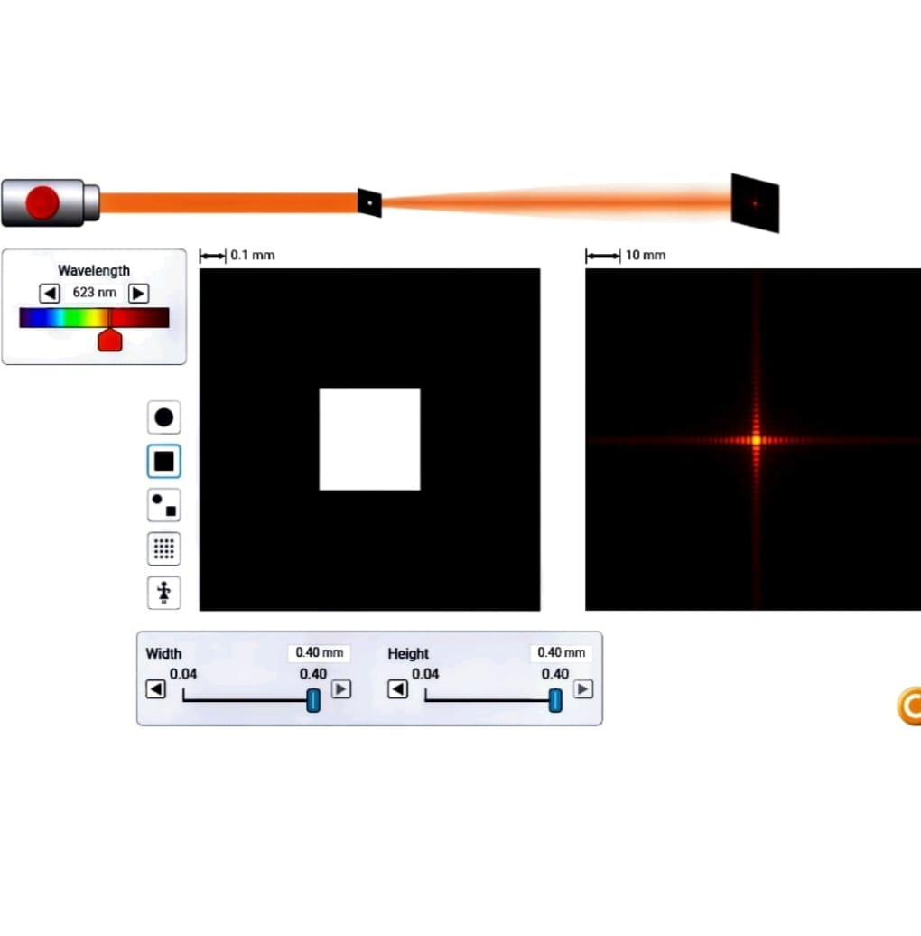

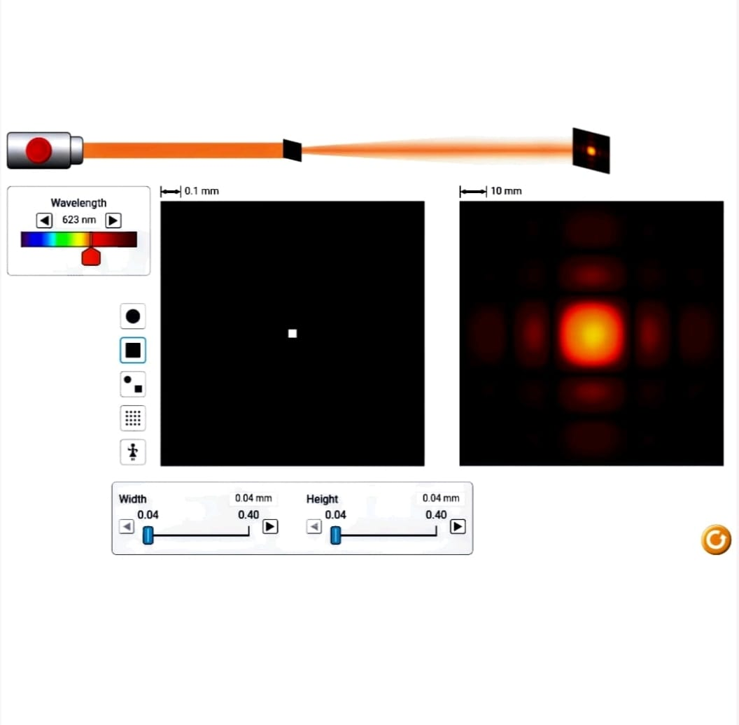

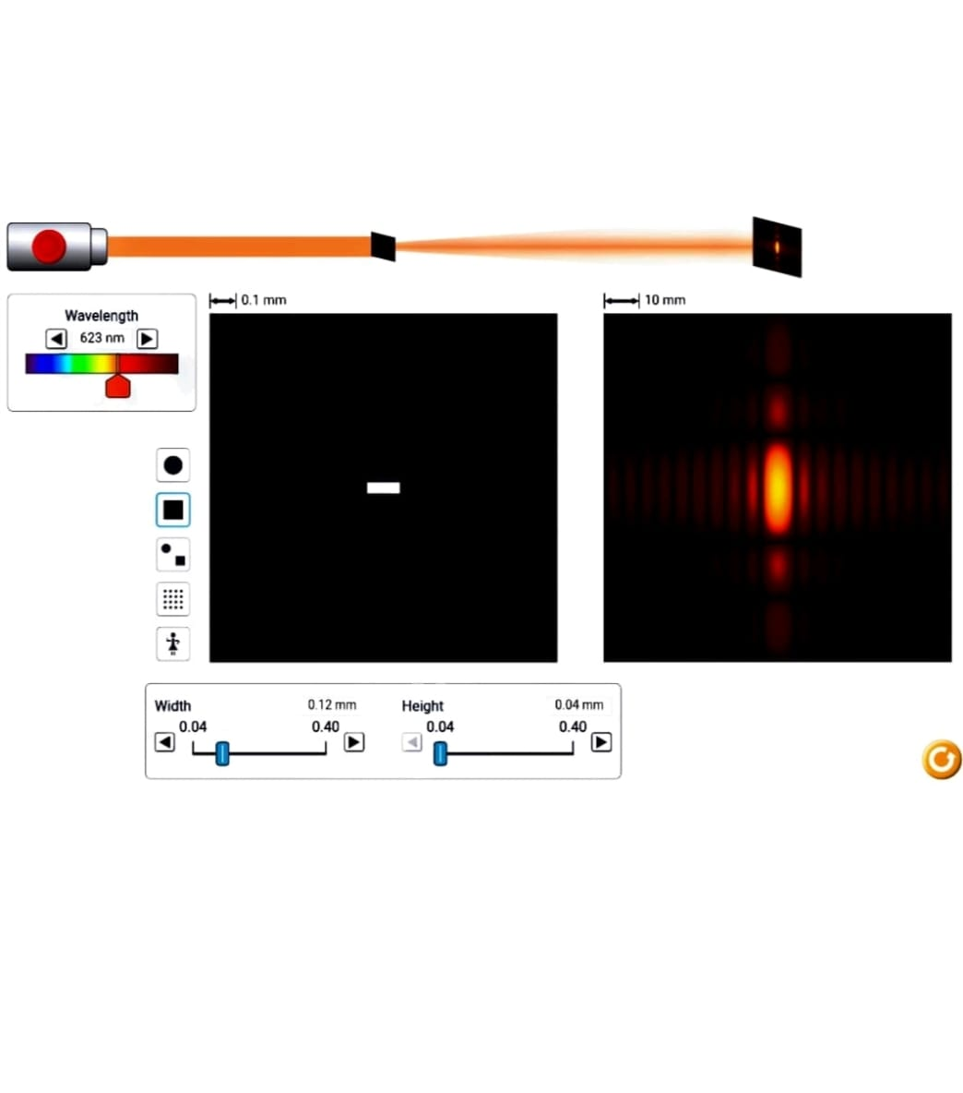

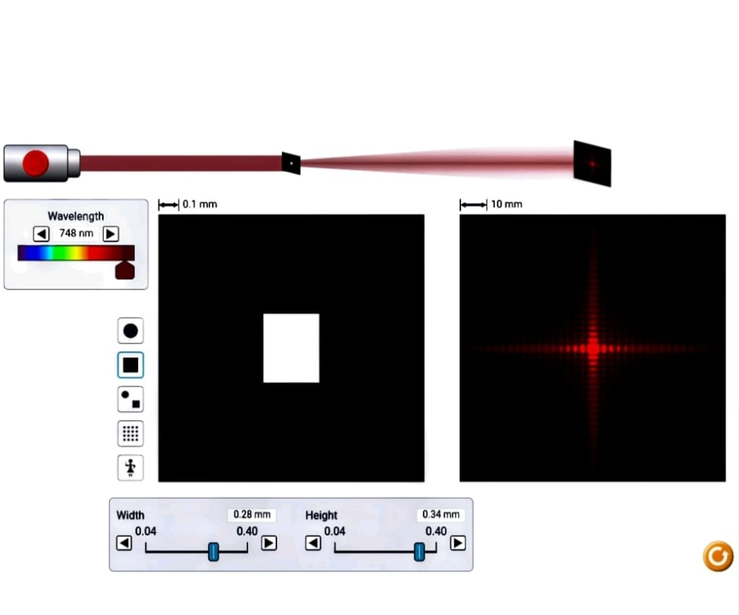

**Result:**

* Thus ΔY (distance between the dark fringes) increases with increase in wavelength of light